Nama : Wanda Ayu Hafidzoh

NIM : 2602199872

## Soal

*Case*

**WatcHGoods**

**WatcHGoods** is home to the greatest collection of used luxury watches, all certified as authentic and Collector Quality. With the growth of information technology, **WatcHGoods** plans to dive into the world of digital business. **WatcHGoods** entrust you as a web designer to design their **website** **prototype** and create the **company** **website**. First, **WatcHGoods** must create a **website** **prototype** and **company** **website** that represents **WatcHGoods** image. With this website's existence, **WatcHGoods** hopes they can improve their service towards their customers.

The **requirements** from **WatcHGoods** are described below:

* + - 1. **WatcHGoods** wants you to design the **website** **prototype** of all **five pages** before making the HTML files. The **website** **prototype** will be created using **Figma**. Ensure the **website** **prototype** that you created is the **exact same** as the website that you will make later. Each pagewill contain **header**, **navigation**, **content,** and **footer** as its structure. Consider the **color**, **layout**, and **consistency** when designing the prototype.
      2. **WatcHGoods** wants you to build the **website attractive**, **appealing** and **fully functional**, and make sure the website is **responsive**. The website should be accessible using a mobile phone in a perfect way. To achieve that, use **5 kinds of CSS property** and **JavaScript**. Use **Meta** **viewport** **tag** and **media** **screen** **rule** that will be applied if the screen is **below** **800px** screen width.
      3. The website consists of **five main pages**. They are **Home Page**, **Products Page**, **About Us Page**, **Locations Page**, **Contact Us Page**. Below are the **requirements** for each page:
  1. **Home**

This page shows the **all the WatcHGoods attributes** (quality, service, authenticity, etc.)and **promotion** **banner** for the customer. This page also shows **all** **watch brands** in **WatcHGoods**.

* 1. **Products**

This page shows **a list of watches** that are currently being sold at the store. **WatcHGoods** wants the **watch** to be **categorized according to its brand**. Each **watch** has its own **information**, such as the **watch** **image**, **name**, and **price**.

* 1. **About Us**

This page shows **information about the** **store’s description** along with some **photos** for decoration.

* 1. **Locations**

This page shows **the locations** of **WatcHGoods physical stores** around the world. In this page, each location will have its own **information**, such as **image**, **city/store name**, and **country**.

* 1. **Contact Us**

This page shows the store’s **contact form** for the customer. Customer needs to submit some **personal information**, such as **full name**, **email**, **country region**, **email body (message),** and a **agreement** to receive a copy of their message. You are also asked to create **5 kinds of form components** and **5 kinds of validation**. For validation, you must create it using **JavaScript** and **don’t use regular expression**.

**Guidelines:**

* + - * 1. Design your website by observing the principles of **human and computer interaction**. Set up your site as creative as possible but still strive for **consistency**.
        2. The **website prototype** must be designed using **Figma** and make surethese **features** are used:
* Color Style & Text Style
* Effects
* Components
* Variants & Interactive Component
* Navigation
  + - * 1. Consider the **color**, **font**, **image**, **size,** and **layout** that you use to design the prototype and website.
        2. All **pages mentioned in the requirement** should be created **based on your template design**.
        3. Use only **external** **CSS**. **Internal** or **inline** **CSS** will not be **marked**.
        4. Use **CSS box positioning concept** to design your web structure**, do not use table for the layout.**
        5. Consider the language you use, including spelling and grammar, feel free to choose either **Bahasa** or **English**, but you cannot have both at the same time.
        6. Make your website **responsive** so it can deliver in any size, particularly for **desktops**, **tablets,** and **mobile devices**.
        7. Organize your files with subdirectories.
        8. Include references (link from a website, book) that you use in creating the website.

Dokumentasi Proyek Website HCI

Website ini dibuat untuk memudahkan watchgoods memasuki era digital yang dimana kebanyakan dari penjualan seperti ii sudah beralih ke e-commerence untuk meningkatkan bisnisnya.

* Home Page

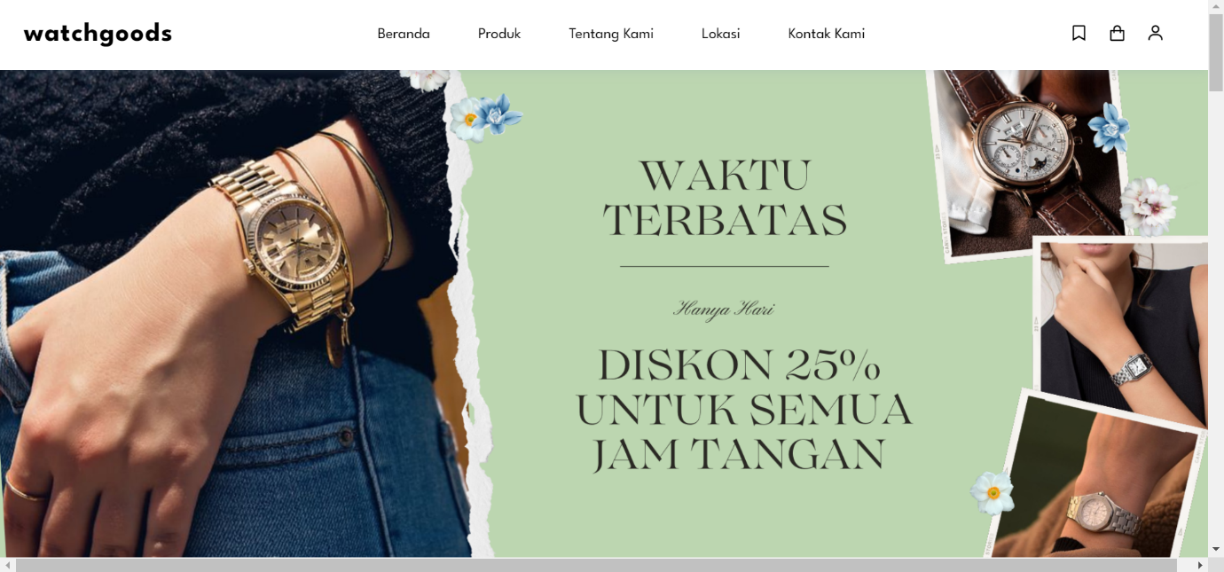

Awalan homepage saya memberikan banner diskon agar user langsung dapat melihat

Dibawah banner saya memberikan atribut website kami agar user bisa mempercayai website kami dengan kami berikan atribut kami pada awalan website

Dibawah banner saya menampilkan koleksi brand yang berkerjasama dengan website kami dan kolaksi yang kami perjualkan di website kami ini agar user bisa mengetahui brand-brand apa saja yang ada di kami

Dibawah brand yang telah kami tampilkan kami juga menampilkan berbagai produk yang kami jual sehingga user dapat dengan mudah melihat produk-produk yang kami jual

Saya memberikan footer yang berfungsi sebagai informasi untuk user jika adanya kendala terhadap website atau pemesanan di website kami serta promosi dan mengnai pembayaran yang didukung oleh website kami.

* Produk

Dibagian produk kami memberikan kategori brand kami jadi user bisa memilih brand yang diinginkan dengan cepat

Lalu di bagian produk kamu juga memperlihatkan berbagai produk yang kami jual seperti yang kami tampilkan di home

Saya juga memberikan footer yang berfungsi sebagai informasi untuk user jika adanya kendala terhadap website atau pemesanan di website kami serta promosi dan mengnai pembayaran yang didukung oleh website kami. Saya memasukan footer ke dalam setiap web saya

Dibagian produk jika user menekan foto produk akan keluar penjelasan dan juga harga produk, contohnya produk rolex yang saya tekan dan muncul penjelasan mengenai produk rolex ini.

* Tentang

Di bagian tentang kami, saya memberikan banner untuk mempercantik bagian, lalu dibawahnya

Terdapat berbagai penjelasan mengenai website kami dan juga mengengai watchgoods, serta atribut dan perbedaan watchgoods dari yang lain.

Saya juga memberikan footer yang berfungsi sebagai informasi untuk user jika adanya kendala terhadap website atau pemesanan di website kami serta promosi dan mengnai pembayaran yang didukung oleh website kami. Saya memasukan footer ke dalam setiap web saya

* Lokasi

Dalam bagian lokasi saya memberikan penampilan map mengenai lokasi toko

Dibawah map juga ada nama dan kota dimana toko berada serta footer yang selalu saya sertakan di setiap bagian web

* Kontak

Saya memberikan banner bertulisan kontak kami untuk mempercantik website dan juga menginformasikan user mengenai bagian ini

Dibagian bawah saya berikan form untuk user memberikan keluh kesan atau bantuan ke pihak kami

Lalu dibawah seperti biasa saya memberikan footer seperti bagian web saya yang lain.

FIGMA

Link Figma :

<https://www.figma.com/proto/VgHj1AUZ85w37zO1hObdjN/AOL-PROJECT?type=design&node-id=2-2&scaling=min-zoom&page-id=0%3A1&starting-point-node-id=2%3A2>

Referensi

<https://www.w3schools.com/css/css_rwd_images.asp>

<https://www.w3schools.com/tags/att_input_type_checkbox.asp>

<https://www.youtube.com/watch?v=7pRZUG1gKfQ&t=93s>

<https://www.youtube.com/watch?v=RDDK5dci1mQ&t=45s>

<https://www.youtube.com/watch?v=KjJs7BXicCE&t=70s>

<https://www.youtube.com/watch?v=YIVXOMvXmNE&t=692s>

<https://www.omegawatches.com/>

<https://www.hublot.com/en-id/watches>

<https://www.chorostco.com/collections/cartier-2?gclid=CjwKCAjw-IWkBhBTEiwA2exyO3ELbqB5Y3Y9Tz55dPzngtkb0ttd-WT2BQdHYi_dhKDnd2ywpzXSqhoCnP4QAvD_BwE>

<https://www.rolex.com/id/watchmaking/excellence-in-the-making/hallmarks-of-excellence?ef_id=CjwKCAjw-IWkBhBTEiwA2exyOzGPQrGVWOipNUsdorDlc-259obEggfB-r99EHE61NSFCAuN3uWCdRoCSlsQAvD_BwE:G:s&s_kwcid=AL!141!3!660549197650!e!!g!!rolex!8671380850!86525109345>

<https://www.seikowatches.com/id-id/>

<https://www.youtube.com/watch?v=FaNTVjATYHQ>